Lab - Troubleshoot BGP

# Topology

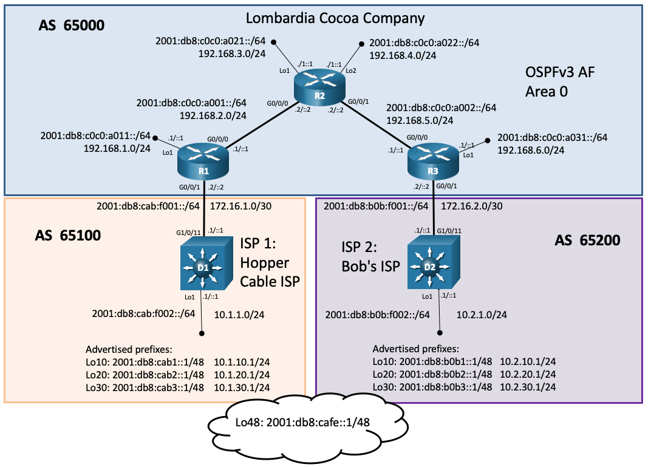

**Note**: The advertised prefixes in AS 65100, 65200 and in the "the cloud" are associated with the interface addresses shown (.1 and ::1) for verification purpose. These prefixes are advertised by D1 and D2 to their respective BGP peers.

**Note**: AS 65100 advertises a shorter AS path to 2001::db8:cafe::/48.

# Addressing Table

| Device | Interface | IPv6 Address IPv4 Address | IPv6 Link-Local |
| --- | --- | --- | --- |
| R1 | G0/0/0 | 2001:db8:c0c0:a001::1/64 | fe80::a001:1 |
| R1 | G0/0/0 | 192.168.2.1/24 | N/A |
| R1 | G0/0/1 | 2001:db8:cab:f001::2/64 | fe80::f001:2 |
| R1 | G0/0/1 | 172.16.1.2/30 | N/A |
| R1 | Lo0 (iBGP Peering) | 2001:db8:c0c0:99::1/128 | fe80::99:1 |
| R1 | Lo0 (iBGP Peering) | 192.168.99.1 | N/A |
| R1 | Lo1 | 2001:db8:c0c0:a011::1/64 | fe80::a011:1 |
| R1 | Lo1 | 192.168.1.1/24 | N/A |
| R2 | G0/0/0 | 2001:db8:c0c0:a001::2/64 | fe80::a001:2 |
| R2 | G0/0/0 | 192.168.2.2/24 | N/A |
| R2 | G0/0/1 | 2001:db8:c0c0:a002::2/64 | fe80::a002:2 |
| R2 | G0/0/1 | 192.168.5.2/24 | N/A |
| R2 | Lo0 (iBGP Peering) | 2001:db8:c0c0:99::2/128 | fe80::99:2 |
| R2 | Lo0 (iBGP Peering) | 192.168.99.2/24 | N/A |
| R2 | Lo1 | 2001:db8:c0c0:a021::1/64 | fe80::a021:1 |
| R2 | Lo1 | 192.168.3.1/24 | N/A |
| R2 | Lo2 | 2001:db8:c0c0:a022::1/64 | fe80::a022:1 |
| R2 | Lo2 | 192.168.4.1/24 | N/A |
| R3 | G0/0/0 | 2001:db8:c0c0:a002::1/64 | fe80::a002:1 |
| R3 | G0/0/0 | 192.168.5.1/24 | N/A |
| R3 | G0/0/1 | 2001:db8:b0b:f001::2/64 | fe80::f001:2 |
| R3 | G0/0/1 | 172.16.2.2/30 | N/A |
| R3 | Lo0 (iBGP Peering) | 2001:db8:c0c0:99::3/128 | fe80::99:3 |
| R3 | Lo0 (iBGP Peering) | 192.168.99.3/24 | N/A |
| R3 | Lo1 | 2001:db8:c0c0:a031::1/64 | fe80::a031:1 |
| R3 | Lo1 | 192.168.6.1/24 | N/A |
| D1 | G1/0/11 | 2001:db8:cab:f001::1/64 | fe80::cab:f001:1 |
| D1 | G1/0/11 | 172.16.1.1/30 | N/A |
| D1 | Lo1 | 2001:db8:cab:f002::1/64 | fe80::cab:f002:1 |
| D1 | Lo1 | 10.1.1.1/24 | N/A |
| D1 | Lo10 | 2001:db8:cab1::1/48 | EUI-64 |
| D1 | Lo10 | 10.1.10.1/24 | N/A |
| D1 | Lo20 | 2001:db8:cab2::1/48 | EUI-64 |
| D1 | Lo20 | 10.1.20.1/24 | N/A |
| D1 | Lo30 | 2001:db8:cab3::1/48 | EUI-64 |
| D1 | Lo30 | 10.1.30.1/24 | N/A |
| D1 | Lo48 | 2001:db8:cafe::1/48 | EUI-64 |
| D2 | G1/0/11 | 2001:db8:b0b:f001::1/64 | EUI-64 |
| D2 | G1/0/11 | 172.16.2.1/30 | N/A |
| D2 | Lo1 | 2001:db8:b0b:f002::1/64 | EUI-64 |
| D2 | Lo1 | 10.2.1.1/24 | N/A |
| D2 | Lo10 | 2001:db8:b0b1::1/48 | EUI-64 |
| D2 | Lo10 | 10.2.10.1/24 | N/A |
| D2 | Lo20 | 2001:db8:b0b2::1/48 | EUI-64 |
| D2 | Lo20 | 10.2.20.1/24 | N/A |
| D2 | Lo30 | 2001:db8:b0b3::1/48 | EUI-64 |
| D2 | Lo30 | 10.2.30.1/24 | N/A |
| D2 | Lo48 | 2001:db8:cafe::1/48 | EUI-64 |

**Note**: To make it easier to recognize IPv6 prefixes, familiarize yourself with the IPv6 GUA and LLA address formats.

* GUA: The GUA has a 16-bit subnet-ID, a<area-id><router><network> ("a" for area). For example, subnet-ID a021 is area 0, router 2, network 1.
* LLA: Following best practice the LLA is unique on each interface. The LLA interface-ID uses the GUA subnet-ID:interface-ID for the last 64 bits. For example, fe80::a201:1 has a LLA interface-ID a201 (the subnet-ID of the GUA) and :1 (the interface ID of the GUA).

# Objectives

Troubleshoot network issues related to the configuration and operation of MP-BGP with address families.

# Background / Scenario

Lombardia Cocoa Company (AS 65000) peers with two ISPs (AS 65100 and AS 65200) and receives the following prefixes from each:

* From ISP1 Hopper Cable ISP (AS 65100):
* 10.1.1.0/24, 10.1.10.0/24, 10.1.20.0/24, 10.1.30.0/24
* 2001:db8:cab:f002::/64, 2001:db8:cab1::/48, 2001:db8:cab2::/48, 2001:db8:cab3::/48, 2001:db8:cafe::/48 (shorter AS path)
* From ISP2 Bob's ISP (AS 65200):
* 10.2.1.0/24, 10.2.10.0/24, 10.2.20.0/24, 10.2.30.0/24
* 2001:db8:b0b:f002::/64, 2001:db8:b0b2::/48, 2001:db8:b0b2::/48, 2001:db8:b0b3::/48, 2001:db8:cafe::/48 (longer AS path)

Both ISPs also receive specific prefixes from Lombardia.

* Lombardia advertises to both ISPs:
* 192.168.1.0/24, 192.168.3.0/24, 192.168.4.0/24, 192.168.6.0/24
* 2001:db8:c0c0:a011::/64, 2001:db8:c0c0:a021::/64, 2001:db8:c0c0:a022::/64, 2001:db8:c0c0:a031::/64

**Note:** Inter-router links are **not** advertised by BGP.

**Note**: Lombardia iBGP peering is done using loopback 0 addresses.

Although the topology has a limited number of routers, you should use the appropriate troubleshooting commands to help find and solve the problems in the three trouble tickets as if this were a much more complex topology with many more routers and networks.

You will be loading configurations with intentional errors onto the network. Your tasks are to FIND the error(s), document your findings and the command(s) or method(s) used to fix them, FIX the issue(s) presented here, and then test the network to ensure both of the following conditions are met:

* + - * 1. the complaint received in the ticket is resolved
        2. full reachability is restored

**Note**: The routers used with CCNP hands-on labs are Cisco 4221 with Cisco IOS XE Release 16.9.4 (universalk9 image). The switches used in the labs are Cisco Catalyst 3650 with Cisco IOS XE Release 16.9.4 (universalk9 image). Other routers, switches, and Cisco IOS versions can be used. Depending on the model and Cisco IOS version, the commands available and the output produced might vary from what is shown in the labs. Refer to the Router Interface Summary Table at the end of the lab for the correct interface identifiers.

**Note**: Make sure that the devices have been erased and have no startup configurations. If you are unsure, contact your instructor.

# Required Resources

* 3 Routers (Cisco 4221 with Cisco IOS XE Release 16.9.4 universal image or comparable)
* 2 Switches (Cisco 3560 with Cisco IOS XE Release 16.9.4 universal image or comparable)
* Console cables to configure the Cisco IOS devices via the console ports
* Ethernet cables as shown in the topology

## Trouble Ticket 14.1.2.1

Scenario:

Lombardia Cocoa Company recently added router R2 between routers R1 and R3. Previously, R1 and R3 were connected directly. Routers R1, R2 and R3 were reconfigured to implement these changes. During testing and validation, the network team noticed that routers R1 and R3 only have BGP routes from their directly connected eBGP peers. All three AS 65000 routers should be receiving routes indicated in the network documentation (see the previous Background / Scenario section).

You have been asked to help find the problem and implement any necessary changes.

Use the commands listed below to load the configuration files for this trouble ticket:

| Device | Command |
| --- | --- |
| R1 | **copy flash:/enarsi/14.1.2.1-r1-config.txt run** |
| R2 | **copy flash:/enarsi/14.1.2.1-r2-config.txt run** |
| R3 | **copy flash:/enarsi/14.1.2.1-r3-config.txt run** |
| D1 | **copy flash:/enarsi/14.1.2.1-d1-config.txt run** |
| D2 | **copy flash:/enarsi/14.1.2.1-d2-config.txt run** |

* All routers should receive the prefixes shown in the previous Background / Scenario section.
* Verification: The following pings should be successful. If a ping does not work, the ticket is not resolved:

R1# **ping 10.2.1.1 source lo1**

R1# **ping 2001:db8:b0b:f002::1 source lo1**

R3# **ping 10.1.1.1 source lo1**

R3# **ping 2001:db8:cab:f002::1 source lo1**

* When you have fixed the ticket, change the MOTD on EACH DEVICE using the following command:

**banner motd # This is $(hostname) FIXED from ticket <ticket number> #**

* Then save the configuration by issuing the **wri** command (on each device).
* Inform your instructor that you are ready for the next ticket.
* After the instructor approves your solution for this ticket, issue the **reset.now** privileged EXEC command. This script will clear your configurations and reload the devices.

## Trouble Ticket 14.1.2.2

Scenario:

The preferred default path to the 2001:db8:cafe::/48 prefix is via AS 65100 because it is a shorter AS path. Your peering agreements with both ISPs state that you have to pay for traffic transiting via AS 65100 but not through AS 65200. To decrease costs, management has tasked the network team to send traffic for 2001:db8:cafe::/48 to AS 65200.

Policy changes were made to forward traffic to the 2001:db8:cafe::/48 prefix to AS 65200. However, verification commands indicate that only router R3 is forwarding traffic to the 2001:db8:cafe::/48 prefix to AS 65200. Routers R1 and R2 are still forwarding traffic for the 2001:db8:cafe::/48 prefix to AS 65100.

You have been tasked to find and resolve the issue.

Use the commands listed below to load the configuration files for this trouble ticket:

|  |  |
| --- | --- |
| Device | Command |
| R1 | **copy flash:/enarsi/14.1.2.2-r1-config.txt run** |
| R2 | **copy flash:/enarsi/14.1.2.2-r2-config.txt run** |
| R3 | **copy flash:/enarsi/14.1.2.2-r3-config.txt run** |
| D1 | **copy flash:/enarsi/14.1.2.2-d1-config.txt run** |
| D2 | **copy flash:/enarsi/14.1.2.2-d2-config.txt run** |

* All AS 65000 routers should forward traffic for 2001:db8:cafe::/48 via AS 65200.
* IPv6 BGP tables in all AS 65000 routers should verify that AS 65200 is the preferred (best) path.
* When you have fixed the ticket, change the MOTD on EACH DEVICE using the following command:

**banner motd # This is $(hostname) FIXED from ticket <ticket number> #**

* Then save the configuration by issuing the **wri** command (on each device).
* Inform your instructor that you are ready for the next ticket.
* After the instructor approves your solution for this ticket, issue the **reset.now** privileged EXEC command. This script will clear your configurations and reload the devices.

# Router Interface Summary Table

| Router Model | Ethernet Interface #1 | Ethernet Interface #2 | Serial Interface #1 | Serial Interface #2 |
| --- | --- | --- | --- | --- |
| 1800 | Fast Ethernet 0/0 (F0/0) | Fast Ethernet 0/1 (F0/1) | Serial 0/0/0 (S0/0/0) | Serial 0/0/1 (S0/0/1) |
| 1900 | Gigabit Ethernet 0/0 (G0/0) | Gigabit Ethernet 0/1 (G0/1) | Serial 0/0/0 (S0/0/0) | Serial 0/0/1 (S0/0/1) |
| 2801 | Fast Ethernet 0/0 (F0/0) | Fast Ethernet 0/1 (F0/1) | Serial 0/1/0 (S0/1/0) | Serial 0/1/1 (S0/1/1) |
| 2811 | Fast Ethernet 0/0 (F0/0) | Fast Ethernet 0/1 (F0/1) | Serial 0/0/0 (S0/0/0) | Serial 0/0/1 (S0/0/1) |
| 2900 | Gigabit Ethernet 0/0 (G0/0) | Gigabit Ethernet 0/1 (G0/1) | Serial 0/0/0 (S0/0/0) | Serial 0/0/1 (S0/0/1) |
| 4221 | Gigabit Ethernet 0/0/0 (G0/0/0) | Gigabit Ethernet 0/0/1 (G0/0/1) | Serial 0/1/0 (S0/1/0) | Serial 0/1/1 (S0/1/1) |
| 4300 | Gigabit Ethernet 0/0/0 (G0/0/0) | Gigabit Ethernet 0/0/1 (G0/0/1) | Serial 0/1/0 (S0/1/0) | Serial 0/1/1 (S0/1/1) |

**Note**: To find out how the router is configured, look at the interfaces to identify the type of router and how many interfaces the router has. There is no way to effectively list all the combinations of configurations for each router class. This table includes identifiers for the possible combinations of Ethernet and Serial interfaces in the device. The table does not include any other type of interface, even though a specific router may contain one. An example of this might be an ISDN BRI interface. The string in parenthesis is the legal abbreviation that can be used in Cisco IOS commands to represent the interface.

End of document